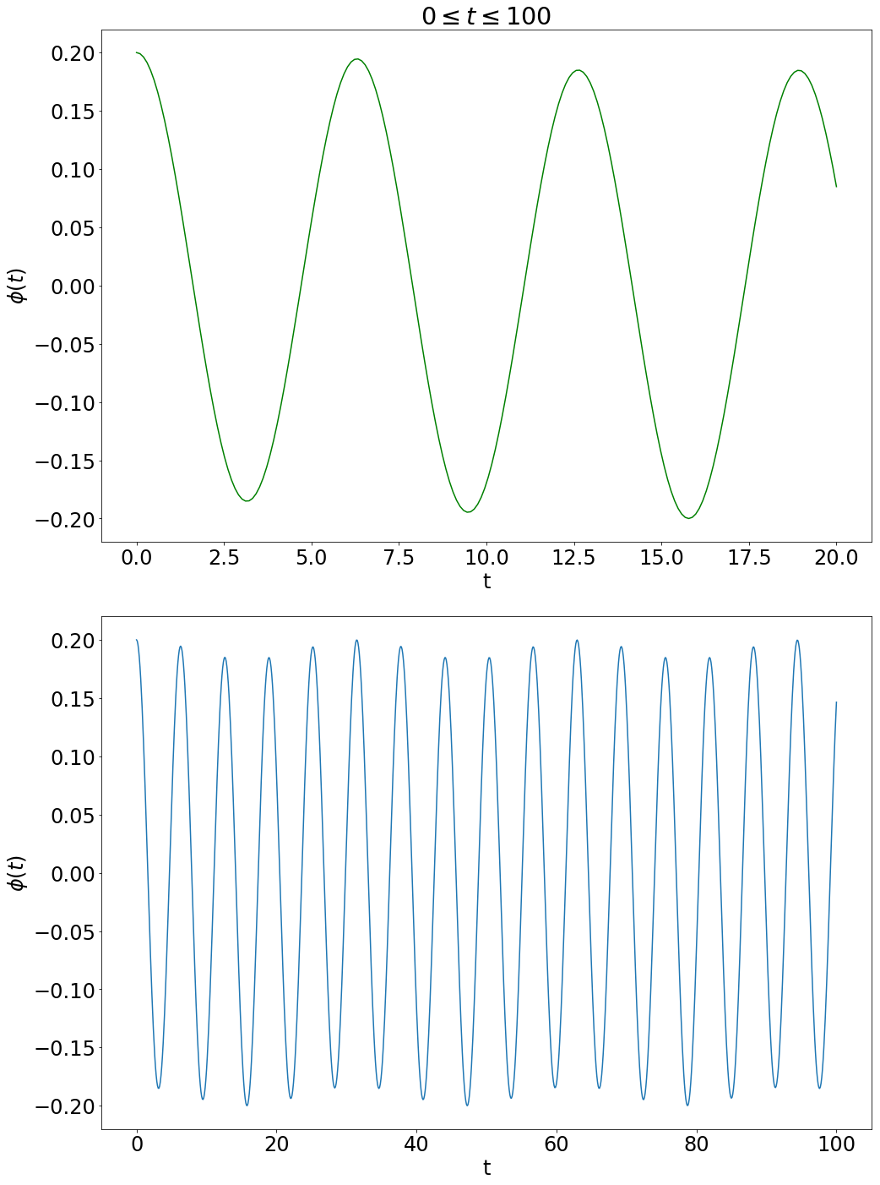7.44) text box above first plot should be 0<t<20 as displayed. The first plot shows seemingly normal cyclic motion with small oscillations of the spinning disk. When increasing time frame, the spinning disk is shown to cyclically affect the pendulums motion. Looking back at first plot, it can be seen that the peaks decrease in amplitude with time but the time frame is too short to begin seeing them increase and decrease cyclically like in second plot from 0<t<100.